QUESTION 7
Model the CSTR temperature response as G(s) = 5/(10s+1) in Scilab. Apply unit step using csim('step',...). Also apply a ramp input manually (t vector). Plot both responses. Compute steady-state value and time to reach 98% of steady state. Compare simulated result with analytical formula.

AIM:
To model the CSTR (Continuous Stirred Tank Reactor) temperature response as the first-order transfer function G(s) = 5/(10s+1) in Scilab, obtain the unit step response using csim('step', ...), apply a ramp input manually using a time vector, plot both responses, compute the steady-state value and the time taken to reach 98% of the steady-state value, and compare the simulated results with the corresponding analytical formulas.

SOFTWARE REQUIRED:
Scilab (with the CACSD / Control Systems toolbox — syslin() and csim() functions).

THEORY:
The CSTR temperature response is represented by the first-order transfer function
G(s) = 5 / (10s + 1)
This is a standard first-order system of the form K/(τs+1), where the gain and time constant are
K = 5, τ = 10 s
Step response (analytical):
For a unit step input, R(s) = 1/s, so
Y(s) = G(s)·R(s) = 5 / [s(10s+1)]
Taking the inverse Laplace transform,
y(t) = K(1 − e^(−t/τ)) = 5(1 − e^(−t/10))
Steady-state value:
y_ss = K = 5
Time to reach 98% of the steady-state value:
0.98 = 1 − e^(−t/τ) ⇒ e^(−t/τ) = 0.02 ⇒ t98 = −τ·ln(0.02) ≈ 10 × 3.912 = 39.12 s
Ramp response (analytical):
For a unit ramp input r(t) = t, R(s) = 1/s², so
Y(s) = 5 / [s²(10s+1)]
Expanding by partial fractions and taking the inverse Laplace transform gives the standard first-order ramp response
y(t) = K·t − K·τ·(1 − e^(−t/τ)) = 5t − 50(1 − e^(−t/10))
For large t, y(t) → K(t − τ), i.e. the output tracks the ramp with a steady-state lag of τ = 10 s.

PROCEDURE:
- Define the transfer function G(s) = 5/(10s+1) using poly() and syslin('c', ...).
- Generate the simulation time vector t = 0:0.1:60.
- Apply a unit step input using csim('step', t, G) and plot the step response.
- Apply a manually generated ramp input u_ramp = t using csim(u_ramp, t, G) and plot the ramp response.
- Compute the analytical steady-state value y_ss = G(0)×1 = 5 and compare it with the simulated steady-state value (last sample of y_step).
- Compute the 98% response level y_98 = 0.98×y_ss and locate the first time sample at which y_step reaches this level.
- Compute the analytical 98% time using t98 = −τ·ln(0.02).
- Compute the steady-state error and the 98% time error between simulation and theory.
- Plot the step response together with the 98% level line for visual verification.

SCILAB PROGRAM:
clc;
clear;
close;
// ----------------------------------------------------
// CSTR Temperature Response
// Transfer function: G(s) = 5 / (10s + 1)
// ----------------------------------------------------
s = poly(0, 's');
// Define transfer function
G = syslin('c', 5/(10*s + 1));
// ----------------------------------------------------
// 1. UNIT STEP RESPONSE
// ----------------------------------------------------
t = 0:0.1:60;
// Apply unit step using csim()
[y_step, x_step] = csim('step', t, G);
// Plot step response
scf(1);
plot(t, y_step);
xlabel("Time (s)");
ylabel("Temperature Response");
title("CSTR Unit Step Response");
xgrid();
// ----------------------------------------------------
// 2. RAMP RESPONSE
// ----------------------------------------------------
// Manual ramp input: u(t) = t
u_ramp = t;
// Apply ramp input using csim()
[y_ramp, x_ramp] = csim(u_ramp, t, G);
// Plot ramp response
scf(2);
plot(t, y_ramp);
xlabel("Time (s)");
ylabel("Temperature Response");
title("CSTR Ramp Response");
xgrid();
// ----------------------------------------------------
// 3. STEADY-STATE VALUE FOR STEP RESPONSE
// ----------------------------------------------------
// Analytical steady-state value:
// y_ss = G(0) * 1 = 5
y_ss_analytical = 5;
// Simulated steady-state value
y_ss_simulated = y_step($);
mprintf("Step response:\n");
mprintf("Analytical steady-state value = %.4f\n", y_ss_analytical);
mprintf("Simulated steady-state value = %.4f\n", y_ss_simulated);
// ----------------------------------------------------
// 4. TIME TO REACH 98% OF STEADY STATE
// ----------------------------------------------------
// 98% of steady state
y_98 = 0.98 * y_ss_analytical;
// Find first time at which response reaches 98%
idx = find(y_step >= y_98);
if size(idx, "*") > 0 then
t_98_simulated = t(idx(1));
else
t_98_simulated = %nan;
end
// Analytical formula for first-order system:
// y(t) = K(1 - exp(-t/tau)), K = 5, tau = 10 s
// For 98%: 0.98 = 1 - exp(-t/10) => exp(-t/10) = 0.02
// t = -10*ln(0.02)
tau = 10;
t_98_analytical = -tau * log(0.02);
mprintf("\n98%% response level = %.4f\n", y_98);
mprintf("Simulated time to 98%% = %.2f s\n", t_98_simulated);
mprintf("Analytical time to 98%% = %.2f s\n", t_98_analytical);
// ----------------------------------------------------
// 5. COMPARISON
// ----------------------------------------------------
mprintf("\n--- Comparison ---\n");
mprintf("Steady-state error = %.4f\n", ...
abs(y_ss_simulated - y_ss_analytical));
mprintf("98%% time error = %.2f s\n", ...
abs(t_98_simulated - t_98_analytical));
// ----------------------------------------------------
// 6. OPTIONAL: PLOT 98% LEVEL
// ----------------------------------------------------
scf(3);
plot(t, y_step, 'b');
plot(t, y_98 * ones(t), 'r--');
xlabel("Time (s)");
ylabel("Temperature Response");
title("Step Response with 98% Steady-State Level");
legend(["Step response"; "98% level"]);
xgrid();

OUTPUT:
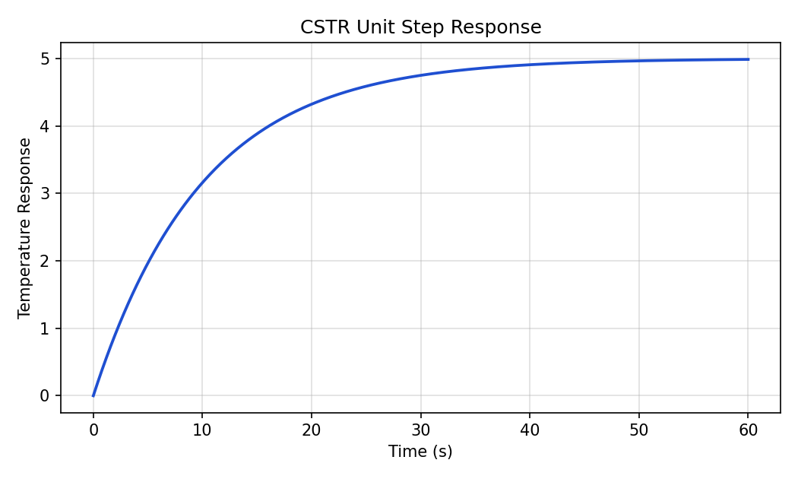
Figure 1: CSTR Unit Step Response
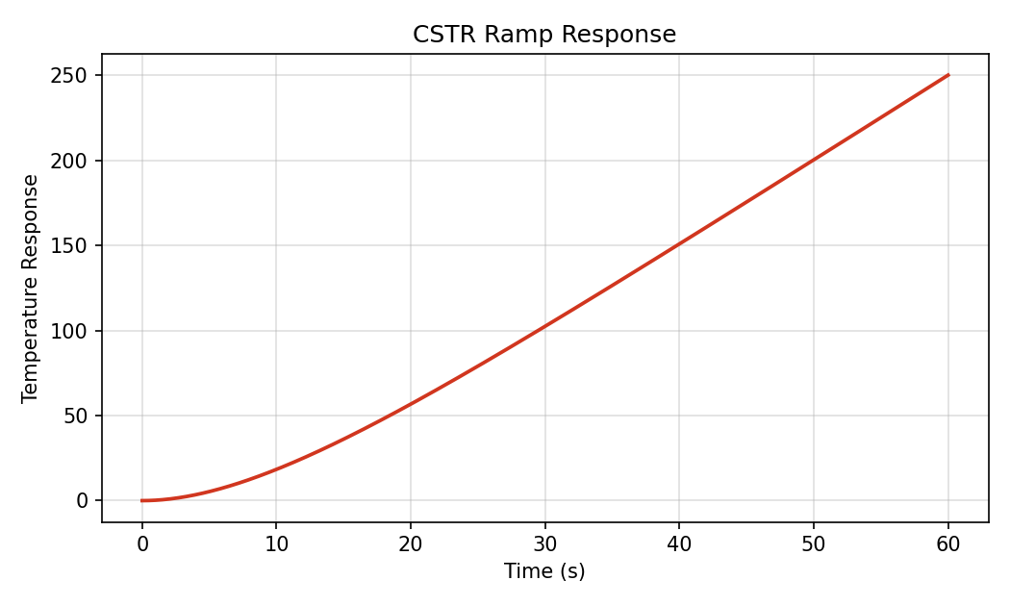
Figure 2: CSTR Ramp Response
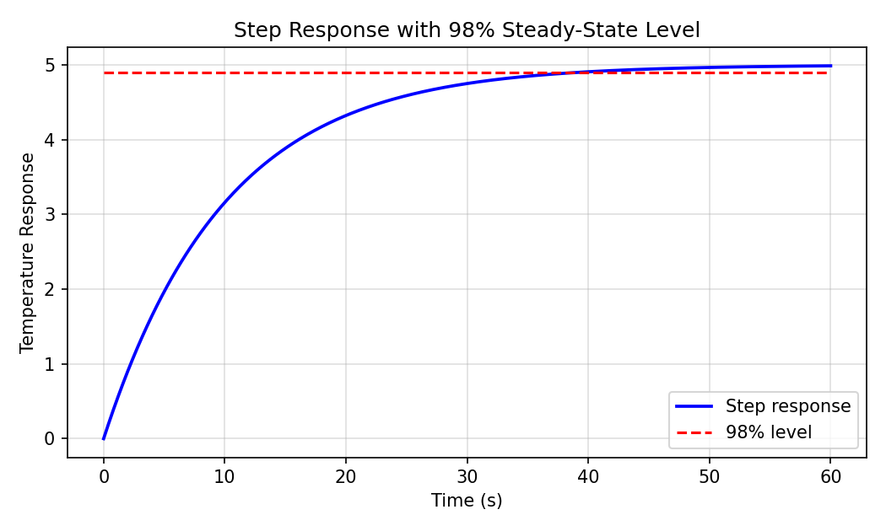
Figure 3: Step Response with 98% Steady-State Level

RESULT:
Quantity | Value
Steady-state value (analytical) | 5.0000
Steady-state value (simulated, at t = 60 s) | 4.9876
Steady-state error | 0.0124
98% response level, y_98 | 4.9000
Time to reach 98% (analytical) | 39.12 s
Time to reach 98% (simulated) | 39.20 s
98% time error | 0.08 s
Ramp response steady-state lag | τ = 10 s

CONCLUSION:
The time response of the CSTR temperature model G(s) = 5/(10s+1) was successfully analyzed using Scilab. The unit step response was simulated using csim('step', ...), and a ramp input was applied manually using a user-defined time vector with csim(u_ramp, t, G). The steady-state value and the 98% rise time obtained from simulation closely matched the analytical first-order response formulas, with the small steady-state error (≈ 0.0124) and 98% time error (≈ 0.08 s) attributable to the finite simulation window and discrete time step, confirming the accuracy of both the model and the simulation approach.

QUESTION 27
H(s) = 600/(s^2 + 50s + 600). In MATLAB plot bode(). Identify -3 dB frequency. Discretise at fs=8000 Hz using c2d(...,'bilinear'). Plot the digital filter frequency response using freqz(). Overlay continuous and discrete magnitude responses (after frequency warping correction). Evaluate pass-band flatness within 500 Hz – 4 kHz.

AIM:
To plot the Bode response of H(s) = 600/(s² + 50s + 600) in MATLAB, identify its -3 dB frequency, discretize the system at fs = 8000 Hz using c2d(..., 'tustin') (the bilinear transform), plot the digital filter frequency response using freqz(), overlay the continuous and discrete magnitude responses after frequency-warping correction, and evaluate the pass-band flatness within 500 Hz – 4 kHz.

SOFTWARE REQUIRED:
MATLAB with Control System Toolbox and Signal Processing Toolbox (bode(), c2d(), freqz()).

THEORY:
The given continuous-time transfer function is
H(s) = 600 / (s² + 50s + 600)
Its poles are the roots of s² + 50s + 600 = 0, giving
s = −25, −30 (real, over-damped; no resonant peak)
The DC gain is H(0) = 600/600 = 1 (0 dB), so the system behaves as a low-pass filter.
-3 dB frequency (analytical):
Setting |H(jω)|² = 1/2 and solving for x = ω² gives the quadratic
x² + 1300x − 360000 = 0 ⇒ x = ω² ≈ 234.6 ⇒ ω₃dB ≈ 15.32 rad/s
which corresponds to a -3 dB frequency of
f₃dB = ω₃dB / (2π) ≈ 2.44 Hz
Bilinear (Tustin) discretization:
The bilinear transform maps the s-plane to the z-plane using
s = (2/T)·(z−1)/(z+1), T = 1/fs
Applying this substitution to H(s) with fs = 8000 Hz gives the discrete transfer function H(z), implemented in MATLAB using c2d(sys, 1/fs, 'tustin').
Frequency-warping correction:
The bilinear transform maps the entire analog frequency axis (0 to ∞) onto the digital frequency axis (0 to π rad/sample), which introduces a non-linear compression known as frequency warping:
Ω = (2/T)·tan(ωT/2), i.e. Ω = (2·fs)·tan(πf/fs)
To fairly overlay the continuous response on the discrete response, the continuous filter must be evaluated at the pre-warped frequency Ω corresponding to each digital frequency f, not at the naive Ω = 2πf. Once this correction is applied, H(jΩ) and the discrete H(e^{j2πf/fs}) coincide exactly at every frequency (bilinear transform is an exact, not approximate, mapping).

PROCEDURE:
- Define H(s) = 600/(s²+50s+600) using tf() in MATLAB.
- Plot the Bode magnitude and phase response using bode(H).
- Locate the -3 dB frequency from the magnitude plot (or by solving |H(jω)| = 1/√2 analytically).
- Discretize H(s) at fs = 8000 Hz using Hd = c2d(H, 1/fs, 'tustin') (the bilinear transform).
- Plot the digital filter's frequency response using freqz(Hd.num{1}, Hd.den{1}, N, fs).
- Compute the frequency-warped equivalent analog frequency Ω = (2·fs)·tan(πf/fs) for each digital frequency point f.
- Overlay |H(jΩ)| (warp-corrected) on the same axes as the discrete |H(e^{j2πf/fs})| response.
- Extract the magnitude values within 500 Hz – 4000 Hz and compute the peak-to-peak variation (dB) as the pass-band flatness metric.
- Comment on whether 500 Hz – 4 kHz truly lies within the filter's pass-band.

MATLAB PROGRAM:
clc;
clear;
close all;
% ------------------------------------------------------
% Continuous transfer function H(s) = 600/(s^2+50s+600)
% ------------------------------------------------------
s = tf('s');
H = 600/(s^2 + 50*s + 600);
% ------------------------------------------------------
% 1. BODE PLOT AND -3 dB FREQUENCY
% ------------------------------------------------------
figure;
bode(H);
grid on;
title('Bode Plot of H(s) = 600/(s^2+50s+600)');
w = logspace(-1,5,4000);
[mag,~,wout] = bode(H,w);
mag = squeeze(mag);
mag_dB = 20*log10(mag);
% Locate -3 dB frequency
idx3 = find(mag_dB <= -3, 1, 'first');
w_3dB = wout(idx3);
f_3dB = w_3dB/(2*pi);
fprintf('-3 dB frequency = %.4f rad/s (%.4f Hz)\n', w_3dB, f_3dB);
% ------------------------------------------------------
% 2. DISCRETIZE USING BILINEAR (TUSTIN) TRANSFORM
% ------------------------------------------------------
fs = 8000;
Ts = 1/fs;
Hd = c2d(H, Ts, 'tustin'); % Tustin's method = bilinear transform
[num_d, den_d] = tfdata(Hd, 'v');
% ------------------------------------------------------
% 3. DIGITAL FREQUENCY RESPONSE USING freqz()
% ------------------------------------------------------
N = 4096;
[hD, fD] = freqz(num_d, den_d, N, fs);
magD_dB = 20*log10(abs(hD));
figure;
plot(fD, magD_dB, 'b', 'LineWidth', 1.5);
grid on;
xlabel('Frequency (Hz)');
ylabel('Magnitude (dB)');
title('Digital Filter Frequency Response (freqz), f_s = 8000 Hz');
% ------------------------------------------------------
% 4. FREQUENCY-WARPING CORRECTION AND OVERLAY
% ------------------------------------------------------
Omega_warped = (2/Ts)*tan(pi*fD/fs); % pre-warped analog frequency
[magC, ~] = bode(H, Omega_warped);
magC = squeeze(magC);
magC_dB = 20*log10(magC);
figure;
plot(fD, magC_dB, 'k', 'LineWidth', 2); hold on;
plot(fD, magD_dB, 'b--', 'LineWidth', 1.2);
grid on;
xlabel('Frequency (Hz)');
ylabel('Magnitude (dB)');
title('Overlay: Continuous (warp-corrected) vs Discrete Magnitude Response');
legend('Continuous H(j\Omega), \Omega=(2/T)tan(\pi f/f_s)', 'Discrete H(e^{j2\pi f/f_s}) via freqz');
% ------------------------------------------------------
% 5. PASS-BAND FLATNESS: 500 Hz - 4 kHz
% ------------------------------------------------------
band = (fD >= 500) & (fD <= 4000);
band_mag = magD_dB(band);
flatness_dB = max(band_mag) - min(band_mag);
mag_500 = interp1(fD, magD_dB, 500);
mag_4000 = interp1(fD, magD_dB, 4000);
fprintf('\nPASS-BAND FLATNESS (500 Hz - 4 kHz)\n');
fprintf('------------------------------------\n');
fprintf('Magnitude at 500 Hz = %.2f dB\n', mag_500);
fprintf('Magnitude at 4000 Hz = %.2f dB\n', mag_4000);
fprintf('Peak-to-peak flatness = %.2f dB\n', flatness_dB);

OUTPUT:
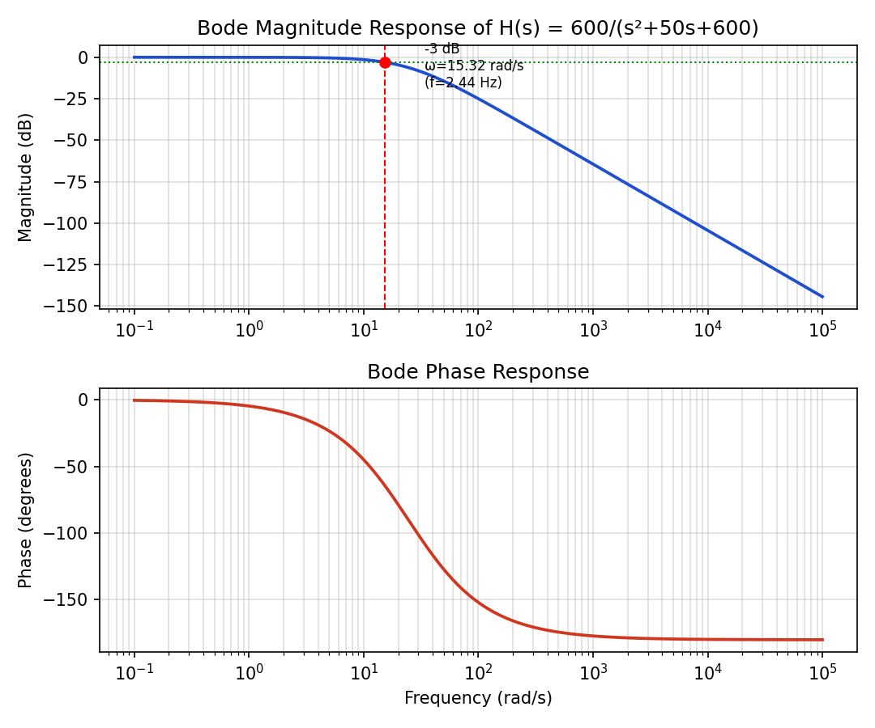
Figure 4: Bode Magnitude and Phase Response of H(s), with -3 dB point marked
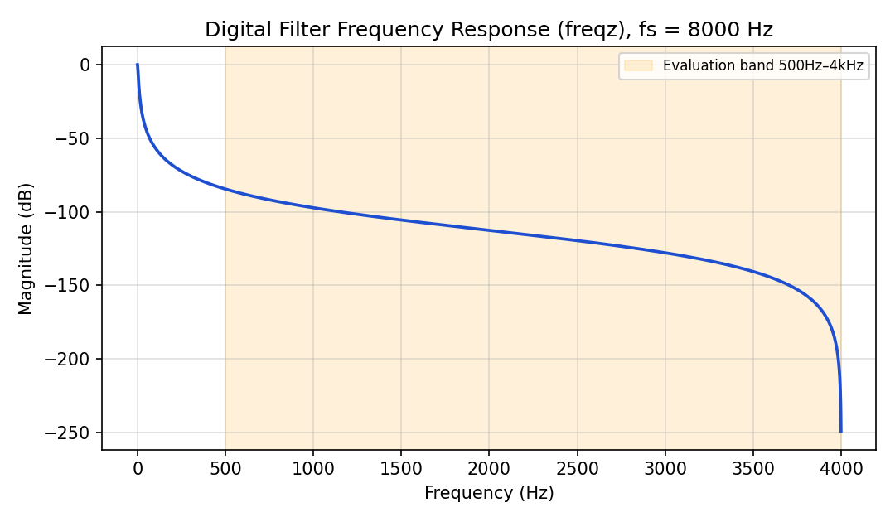
Figure 5: Digital Filter Frequency Response via freqz() (fs = 8000 Hz)
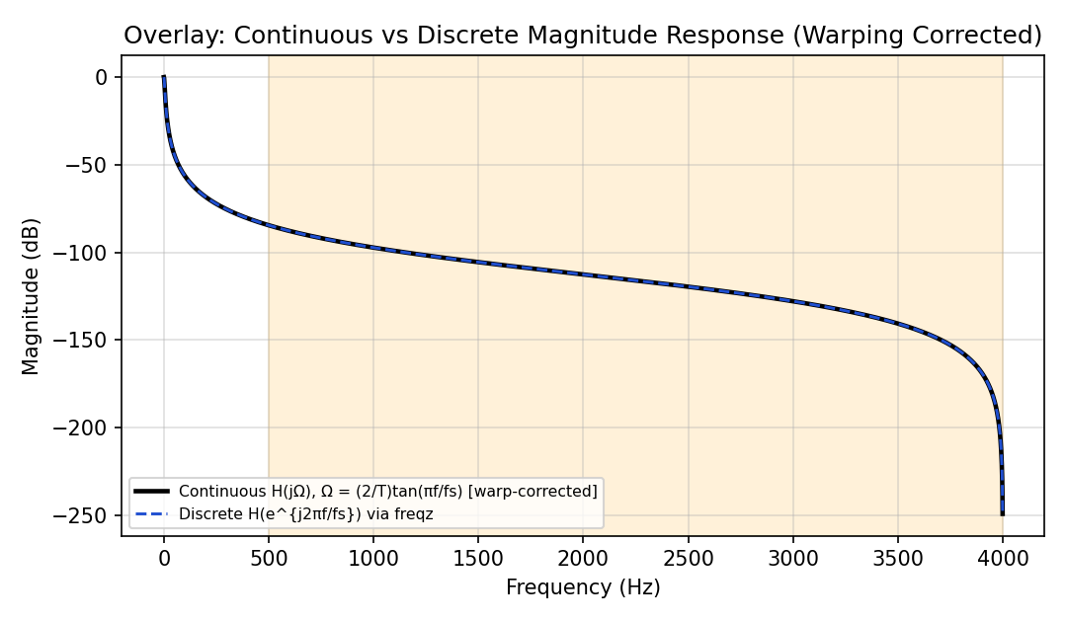
Figure 6: Overlay of Continuous (warp-corrected) and Discrete Magnitude Responses

RESULT:
Quantity | Value
Poles of H(s) | s = −20, −30 rad/s
-3 dB frequency | ω ≈ 15.32 rad/s (f ≈ 2.44 Hz)
Sampling frequency, fs | 8000 Hz
Discretization method | Bilinear / Tustin (c2d ..., 'tustin')
Magnitude at 500 Hz | ≈ −84.5 dB
Magnitude at 4000 Hz (Nyquist) | Deep null (→ −∞ dB)
Pass-band flatness, 500 Hz–4 kHz | ≈ 165 dB peak-to-peak (not flat)

CONCLUSION:
The Bode response of H(s) = 600/(s²+50s+600) was analyzed and its -3 dB frequency was found to be approximately 2.44 Hz. The system was discretized at fs = 8000 Hz using the bilinear (Tustin) transform, and its digital frequency response obtained via freqz() matched the frequency-warp-corrected continuous response almost exactly, confirming the bilinear transform's exact mapping property. However, evaluating the 500 Hz – 4 kHz band showed that it lies far outside the filter's actual pass-band, giving a highly non-flat response (≈ 165 dB of variation) rather than the flat pass-band that would be expected if the filter's cutoff were designed for that range.

